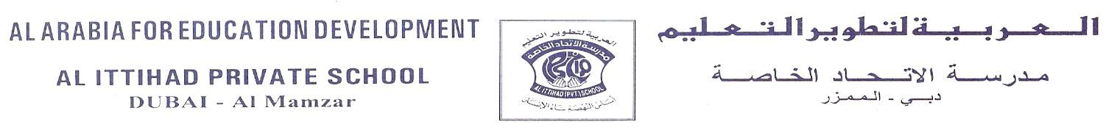
Name | Mohamed Adnan Al Ali
Subject: Chemistry | Lesson: 8.3 Reactivity Series | Grade/Sec:12 C | Date: ₂₆₋₀₉₋₂₀₂₁
NGSS DCI | Structure and Properties of Matter
NGSS EPT | Developing and Using Models
NGSS CCC | Stability and Change

Instructions

Materials:
- well plate / spot plate
- small pieces of magnesium, iron, zinc, and copper metal
- Dilute solutions of hydrochloric acid, copper (II) sulfate, zinc chloride, magnesium chloride, iron (III) sulfate.
- Wash bottle with distilled water
Safety:
-wear goggles
-hydrochloric acid is corrosive "don't touch it or smell it"
-dispose of chemicals in the waste beaker
Procedure:
1- Record the appearance of each metal
2- Using the well plate, combine each type of metal with each solution and with water. Put enough drops of the appropriate solution to completely cover the piece of metal.
3- Record any changes due to a chemical reaction.
In reactions of metal with acid, look carefully for the formation of bubbles. If you are unsure about the observation, repeat the test in a small test tube.
Look for color changes of the surface of the shiny metal or in the solution.
Remember some reactions are slow.
4. clean all spot plates and test tubes, and repeat step 1 and 2 for all the other metals.
5- Dispose of the solutions in the waste beaker supplied, do not pour anything down the drain.
Lab Report
Problem: To check which elements are more reactive
Scientific question: why are some metals are more reactive than others?

Hypothesis: If the elements are higher up in the periodic table then it will be more reactive .
Procedures:
1- Get different types of elements from different groups and periods, and have different solutions with each element dissolved.
2- Mix every element with every different solution (except same element solution) and record what happens.
3- Observe and record which reactions are vigorous and which are calm.

Observation/ collect data:
 | Aqueous Hydrochloric acid  HCl (aq) | Aqueous Copper (II)sulphate  CuSO₄ (aq) | Aqueous Zinc chloride  ZnCl₂ (aq) | Aqueous Magnesium chloride  MgCl₂(aq) | Aqueous Iron (III)chloride  FeCl₃ (aq)
Cu | No reaction |  | Slight bubbling | No reaction | No reaction
Zn | Formation of bubbles, black precipitate | Change in color (from silver to black) |  | No reaction | No reaction
Mg | Formation of bubbles, color change to white, black precipitate | Formation of bubbles, black precipitate | Formation of bubbles |  | Formation of bubbles, black precipitate
Fe | Color change (rusty color) | Color change | No reaction | No reaction

Inference:
It seems that every element which is higher up in the periods, and every element which is closer to group 1 (meaning greater ease of loss of electrons), are more reactive. For example: Cu, which is in group 11, has significantly less reactivity rather than Mg, which is in group 2. It is evident in the reactions that the element which is closer to group 1, Mg, is more clearly reactive.

Analyze and Conclude
- Describe how to predict the arrangement of metals Cu, Mg, Zn and Fe

From the periodic table the element that is in the right is more powerful from the elements in the left and when the metal is in the top it would be more powerful from the element below.

- Infer If a small piece of each metal Cu, Zn, Mg and Fe is added to water, aqueous solution of Magnesium chloride, how might this reflect the data?
There won’t be any reaction because there is no reaction when we added Magnesium to all the solutions

- Analyze Can you predict the arrangement of metals Cu, Zn, Mg and Fe

Yes, with the help of the periodic table and if they are in the top of the periodic table and to the right with more reactivity.

- Infer If a piece of each metal to Cu, Zn, Mg and Fe is added to hydrochloric acid HCl, would you be able to determine the reactivity of H?

With Fe, Zn and Mg there were reactions but with other metals there was no reaction.

- Infer Could there be any hazards associated with the reaction with the hydrochloric acid HCl? If so, what could they be?

There are hazard associated like formation of bubbles and the bubbles released are hydrogen gas this what makes it dangerous and it is very reactive and some time it just change color or there is black precipitate, some elements there are no reaction .

Science Department
Investigation and Inquiry Skills

Criteria |  |  |  | Student-Self check | Teacher’s score | Teacher comment
Safety, Clean up and tidiness  1 mark | Work area was left cleaned. All equipment returned. Student is wearing the Lab coat  1 mark | Work area was partially clean. Most equipment returned. Students is wearing the lab coat.  0.5 Mark | Work area not cleaned. Several  pieces of equipment left on table. Not wearing the Lab coat.  0 Mark
Question and Hypothesis  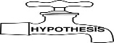  2 marks | The question makes sense and the variable is used in the hypothesis that is clearly states a prediction based on general knowledge and observation and can be tested  2 marks | The question makes sense and no variable used in the hypothesis. The hypothesis states prediction but no evidence of any background knowledge but still allowed for testing.  1 mark | The question does not make sense and the hypothesis is not relevant to the lab. No hypothesis is given.  0.5 mark
Conduct the experiment  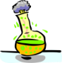  3 marks | Procedures were followed, and applied independently  3 marks | Procedures were followed and applied with guided assistance from the teacher  2 marks | Procedures were followed and applied with direct instruction from the teacher  1 mark
Analyze the result  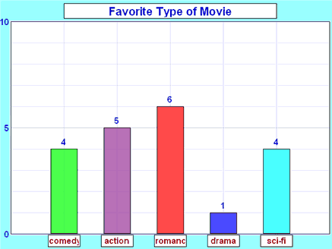  3 marks | Data was collected and ordered in an orderly manner that accurately reflects the results of the experiment. Data table and graph are accurately labeled, drawn, and information is correct  3 marks | Data was recorded in a manner that probably presents the results of the experiment.  Data table and graph are somewhat accurately labeled, drawn. There may be information missing.  2 marks | Data was recorded in an incomplete, random manner or only after considerable teacher assistance.  Data table and graph contain errors in labels, drawing and/or information.  1 mark
Conclude  1 mark | Result and conclusion are accurate and clear. Report shows that student understands the results and knows how to explain them.  1 mark | Result and conclusion are partially accurate and clear. Student can only explain after questioning.  0.5 mark | Result and conclusion are inaccurate and unclear and lead to confusion. Student is unable to explain  0.25 mark
Total |  |  |  |  | /10

