Name | Mohamed Adnan Al Ali
Subject: Chemistry | Lesson: Performance Task  (Reaction Kinetics) | Grade/Sec:12C | Date:
NGSS DCI | Structure and Properties of Matter
NGSS EPT | Developing and Using Models
NGSS CCC | Stability and Change

Factors Influencing Reaction Rate
How do the type of reactants, surface area of reactants, concentration of reactants, and catalysts affect the rates of chemical reactions?

MATERIALS
- Bunsen burner
- Copper foil strip
- Zinc granules
- Magnesium ribbon
- graduated cylinder, 10 mL
- magnesium ribbon
- sandpaper
- steel wool
- 0.1 M Hydrochloric acid
- 6 test tubes
- 20 cm³ beaker
- tongs
Always wear safety goggles and a lab apron to protect your eyes and clothing. If you get a chemical in your eyes, immediately flush the chemical out at the eyewash station while calling to your teacher. Know the locations of the emergency lab shower and the eyewash station and the procedures for using them.

Procedures

Remove all combustible material from the work area.

- Add 10 mL of 1 M Hydrochloric acid each of three test tubes. To one test tube, add a 3 g piece of magnesium ribbon; to a second tube add a 3 g zinc strip; and to a third tube add a 3 g copper strip. (All metals should be the same width.) If necessary, polish the metals with sandpaper until they are shiny. Record your results in Data Table 1.
- Add 10 mL of 1 M Hydrochloric acid to each of two test tubes, add a 3 cm piece of magnesium ribbon to the first test tube and 3 cm magnesium ribbon crushed to the second test tube. Record your results in Data Table 2.

Factors Influencing Reaction Rate Collecting data

Data Table 1
10 mL 1M Hydrochloric acid + Mg ribbon | 10 mL 1M Hydrochloric acid + Zn strip | 10 mL 1M Hydrochloric acid + Cu strip
Intense formation of bubbles  Gas  Produced heat  Smell  Color change | Slight Formation of bubbles  endo thermic reaction | No reaction

Data Table 2
10 mL 1 M Hydrochloric acid + 3 gm Mg ribbon | 10 mL 1 M Hydrochloric acid +3 gm Mg ribbon crushed
Vagarious formation of bubbles  Heat produced  Gas  Color change | Vagarious formation of bubbles  Color change  Heat produced  Gas

Factors Influencing Reaction Rate

DISCUSSION
- What is the rate-influencing factors in each step of the procedure?
Table 1 Due to the activity series some reaction occurred and some not
Table 2 Due to more surface area one reaction was faster than the other

- What were the results from each step of the procedure? How do you interpret each result?
Type of reactant will be different due to their activity series the metals that are in the top in the periodic table will be more reactive
Surface area makes much different the metals that has more surface area will react more than the one that does not have much surface area because the particles can move faster.

- What is your inference about the factors that influence the rate of chemical reaction?
The more the surface area the more reactivity and more collagen
The high activity series the more reactive and more kinetic energy more collagen

Science Department
Investigation and Inquiry Skills

Criteria |  |  |  | Student-Self check | Teacher’s score | Teacher comment
Safety, Clean up and tidiness  1 mark | Work area was left cleaned. All equipment returned. Student is wearing the Lab coat  1 mark | Work area was partially clean. Most equipment returned. Students is wearing the lab coat.  0.5 Mark | Work area not cleaned. Several  pieces of equipment left on table. Not wearing the Lab coat.  0 Mark
Question and Hypothesis  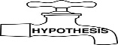  2 marks | The question makes sense and the variable is used in the hypothesis that is clearly states a prediction based on general knowledge and observation and can be tested  2 marks | The question makes sense and no variable used in the hypothesis. The hypothesis states prediction but no evidence of any background knowledge but still allowed for testing.  1 mark | The question does not make sense and the hypothesis is not relevant to the lab. No hypothesis is given.  0.5 mark
Conduct the experiment  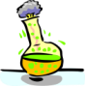  3 marks | Procedures were followed, and applied independently  3 marks | Procedures were followed and applied with guided assistance from the teacher  2 marks | Procedures were followed and applied with direct instruction from the teacher  1 mark
Analyze the result  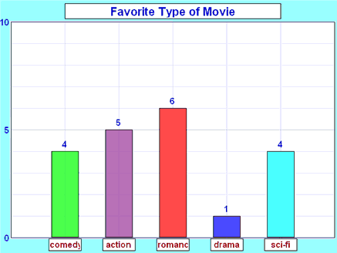  3 marks | Data was collected and ordered in an orderly manner that accurately reflects the results of the experiment. Data table and graph are accurately labeled, drawn, and information is correct  3 marks | Data was recorded in a manner that probably presents the results of the experiment.  Data table and graph are somewhat accurately labeled, drawn. There may be information missing.  2 marks | Data was recorded in an incomplete, random manner or only after considerable teacher assistance.  Data table and graph contain errors in labels, drawing and/or information.  1 mark
Conclude  1 mark | Result and conclusion are accurate and clear. Report shows that student understands the results and knows how to explain them.  1 mark | Result and conclusion are partially accurate and clear. Student can only explain after questioning.  0.5 mark | Result and conclusion are inaccurate and unclear and lead to confusion. Student is unable to explain  0.25 mark
Total |  |  |  |  | /10

